HOTEL RESERVATION FORM (ACM SAC 2014)
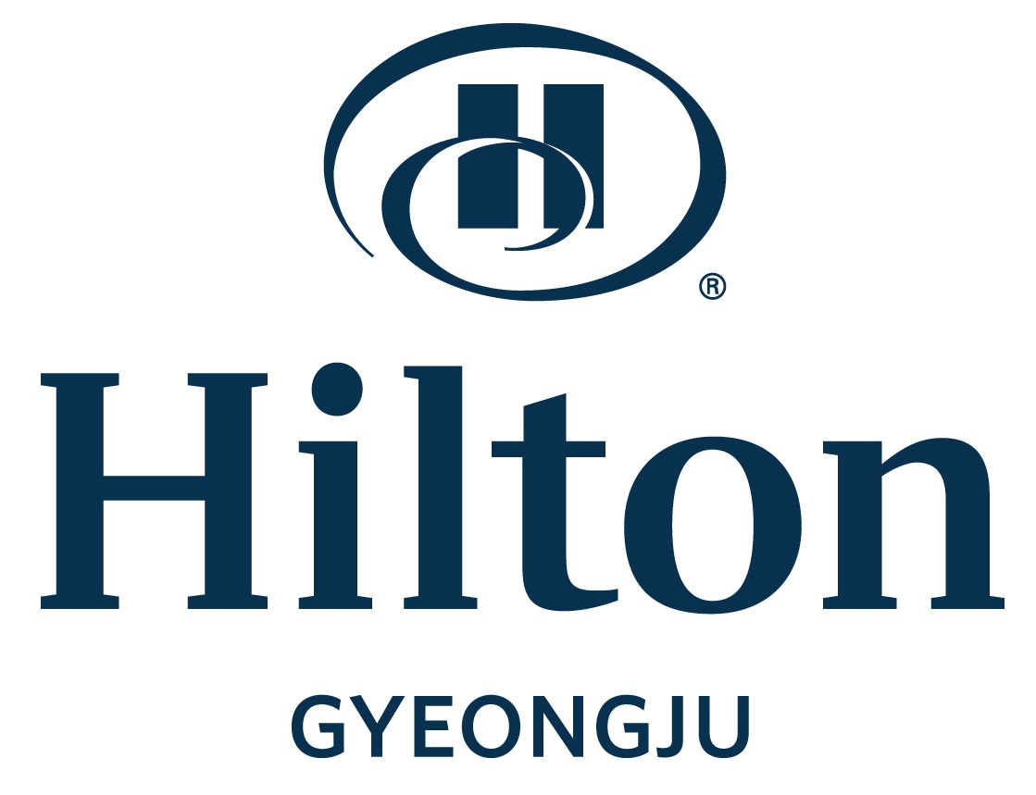 |  | Hilton Gyeongju  370 Shunpyung-dong, Gyeongju 780-290, Korea  Tel: +82-54-740-1234 / Fax: +82-54-745-7799,  E-mail: Yunsik.ho@hilton.com  Website: Go to http://www.hilton.com (Search for Gyeongju, Korea.)
Please fill out this Hotel Reservation Form and send it to the hotel directly by fax (+82-54-745-7799)
Reservation status: Please contact Room Reservation Office
Voice: +82 2 756 9662, Fax: +82 2 771 1561, Email: E-mail: reservation.gyeongju@hilton.com

Section A. Personal Information (* Required Fields)
FIRST NAME* LAST NAME*
AFFILIATION* COUNTRY*
TEL* FAX* E-MAIL*
Section B. CHECK IN & Check out
Check in |  | (time)/ (date)
Check out |  | (date)
SECTION C. room rate
Room Type |  |  | Room rate per night
□ Deluxe Room – single bed (room only) |  |  | US$109 (includes 10% service charge and 10% V.A.T.)
□ Deluxe Room – single bed (room + 1 breakfast) |  |  | US$129 (includes 10% service charge and 10% V.A.T.)
□ Deluxe Room – double beds (room only) |  |  | US$109 (includes 10% service charge and 10% V.A.T.)
□ Deluxe Room – double beds (room + 1 breakfast) |  |  | US$129 (includes 10% service charge and 10% V.A.T.)
□ Additional breakfast / person |  |  | US$20 (includes 10% service charge and 10% V.A.T.)
Section D. Hotel deposit (Please check one of the following payment method)
To secure your reservation, a deposit equivalent to one night’s room rate must be guaranteed.
 Payment using  credit card | □ Visa □ Master □ Diners Club □ AMEX □ JCB
 Payment using  credit card | Card Number: |  |  | Expiration Date: (Month)/ (Year)
 Payment using  credit card | Name of Card Holder:
 Payment using  credit card | Authorized signature:
Special Comment

*NOTES:
1. Cancellation made before 7 days prior to arrival: No charge
2. Cancellation made before 3 days prior to arrival: 30% of one night room charge
3. Cancellation made before 2 days prior to arrival: 50% of one night room charge
4. Cancellation made on arrival day or No Show: 100% of one night room charge
5. The room rate includes Free WiFi
*** The number of blocked rooms will be only guaranteed by 12:00pm, January 31, 2014 (Korea Time). The reservation is based on first come – first serve.

